**1. Introduction**

This project, "Intelligent Web Crawler & Analyzer," is a sophisticated tool for **ethically extracting and analyzing web data, with a key focus on Amazon.com**. It's designed to overcome the challenges of dynamic web content and anti-bot measures by combining a versatile web crawler with a specialized, JavaScript-enabled scraper. The project offers a user-friendly Streamlit interface for intuitive interaction, data visualization, and comprehensive report generation, providing valuable insights from Amazon's vast product catalog and other online resources.

**2. Robots.txt Rules**

* The robots.txt file specifies which paths are allowed or disallowed for web crawlers (user-agents).
* **2.1 General Rules for All User-agents**

| * • **Disallow: /gp/reader**: Blocks access to Amazon's online content reader pages (e.g., Kindle Cloud Reader). * • **Disallow: /gp/customer-media/upload**: Prevents crawling of customer media upload functionalities. * • **Allow: /wishlist/vendor-button\***: Explicitly permits access to specific vendor-related wishlist button URLs. * • **Disallow: /gp/wishlist/**: Broadly blocks access to general Amazon wishlist pages, typically for privacy. |
| --- |

### 3. Test URLs for robots.txt Compliance

To validate the robots.txt analysis and demonstrate ethical crawling behavior, the following Amazon URLs are used for testing:

* https://www.amazon.com/gp/product/B09G3HRMVB
* https://www.amazon.com/gp/cart
* https://www.amazon.com/s?k=laptops
* https://www.amazon.com/gp/help/customer/contact-us

These specific Amazon URLs are used to **validate the project's adherence to robots.txt rules**, testing both permitted and disallowed paths

## 4. Crawl Delay

This project **builds in a 2-second delay** between web requests, even without a Crawl-delay in Amazon's robots.txt. This deliberate pause ensures the crawler operates politely, protecting server performance and reducing the chance of blocking.

## 5. Crawling Implementation

The project's crawling and scraping strategy is built upon core principles to ensure both effectiveness and ethical operation, particularly when interacting with a large platform like Amazon.

* **Strict robots.txt Adherence:** All components of the crawler are designed to strictly obey Amazon's robots.txt rules, actively avoiding disallowed paths such as login pages, private APIs, and specific internal directories.
* **Clear User-Agent Identification:** All HTTP requests sent by the crawler include a **realistic and randomized User-Agent string**. This helps identify the bot and simulates human-like Browse, reducing the chances of being flagged as suspicious.
* **Polite Delays Between Requests:** A crucial part of ethical crawling is managing request frequency. The project **introduces deliberate delays, typically 2 seconds**, between consecutive requests. This practice prevents overwhelming Amazon's servers and is essential for avoiding anti-bot detection, especially since Amazon's robots.txt does not specify a Crawl-delay.
* **Targeted URL Discovery:** Instead of relying on sitemaps or RSS feeds (which are not suitable for public product data on Amazon), the project uses:
  + **Programmatic URL Construction:** For Amazon's search results, URLs are systematically generated based on keywords and page numbers.
  + **Link Extraction:** From the fetched search result pages, individual product URLs are extracted through HTML parsing.

### Core Implementation Workflow:

A Python-based workflow is implemented to efficiently collect product data from Amazon:

1. **Search Query Execution:** The crawler begins by sending search queries to Amazon, often leveraging **ScraperAPI** to reliably fetch the initial search results HTML.
2. **Product Link Discovery:** From these search result pages, the relevant product URLs are extracted using **BeautifulSoup**.
3. **Detailed Product Scraping:** For each discovered product URL, **Selenium** (controlling a headless Chrome browser) is employed. This allows for the full rendering of dynamic JavaScript content on product pages, ensuring all details like product name, price, and description are loaded and available for extraction.
4. **Data Structuring:** The scraped product data is then organized into a **Pandas DataFrame** for easy analysis and reporting.

This meticulous implementation ensures that the project gathers comprehensive product information while maintaining a responsible and sustainable interaction with Amazon's website.

## 6. Alternative Data Access Methods

This section explores other structured data access methods offered by Amazon, highlighting their relevance and how this project chooses to interact with them.

### 6.1 Amazon Associates API (Product Advertising API)

Amazon offers an **official Product Advertising API (PA API)**, formerly known as the Amazon Associates API. This is a legitimate way for developers to programmatically access product information, search results, and more. Access typically requires registration as an Amazon Associate and often involves rate limits and specific usage policies.

* **Project's Approach:** This project, while recognizing the existence of the PA API, **does not directly utilize it for data extraction.** Instead, it focuses on web scraping public-facing HTML content, particularly through the use of browser automation (Selenium) and proxy services (ScraperAPI), to achieve its data collection goals. This approach allows for greater flexibility in targeting specific data points or pages that might not be fully exposed or easily queryable via the PA API, or to bypass its often strict rate limits.

### 6.2 Amazon Product Data Feeds (for Sellers/Vendors)

Amazon also provides various data feeds, often in XML or flat file formats, to registered sellers and vendors (e.g., through Amazon Seller Central or Vendor Central). These feeds are designed for bulk management of product listings, inventory, and order processing for businesses that sell on Amazon.

* **Project's Approach:** These specialized product data feeds are **private channels intended for Amazon's business partners** and are not publicly accessible to general web crawlers. Consequently, this project does not attempt to access or leverage these feeds. Its focus remains on the publicly visible product information available on the Amazon website, extracted through controlled and ethical web scraping techniques.

## 7. Articles Crawling (HTML Content Extractor)

This component represents a **specialized module within the project designed for extracting structured article content** from various news or content-based websites. While the primary focus of the detailed implementation provided is Amazon product scraping, this "HTML Content Extractor" demonstrates the project's broader capability to handle diverse web data sources.

### Purpose & Functionality:

This module focuses on extracting specific, granular details from articles, such as:

* **Titles:** The main heading of the article.
* **Authors:** The credited writer(s) of the content.
* **Text:** The full body of the article, often requiring cleaning and concatenation.

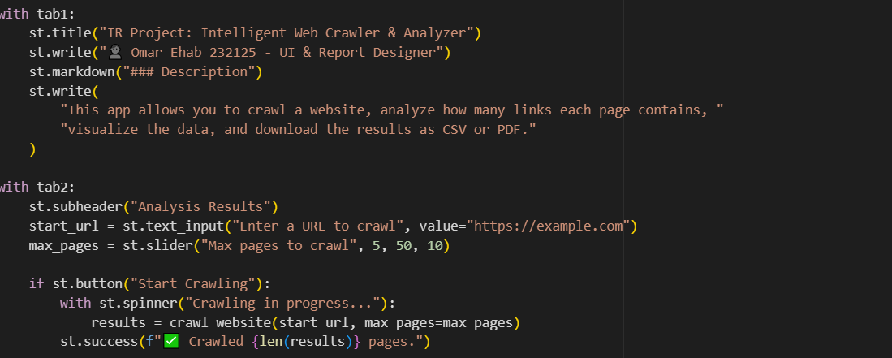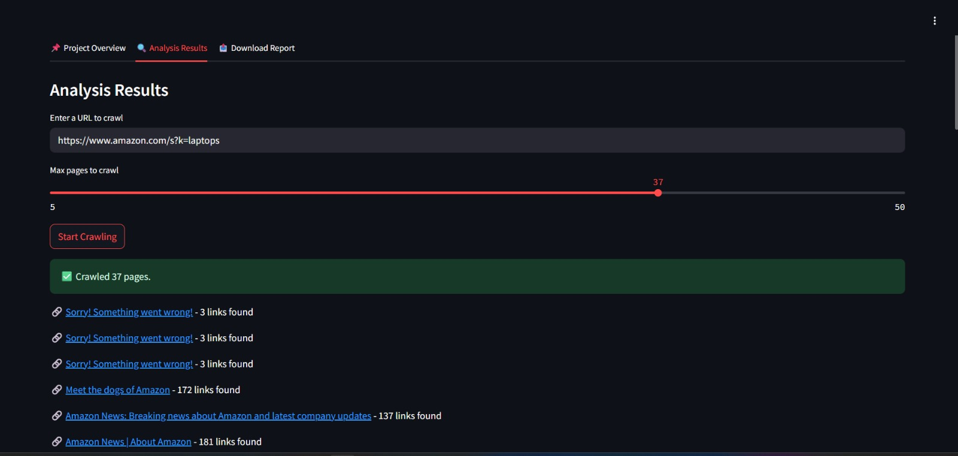

## 8. Example Amazon Product Scraping Workflow

This log demonstrates a typical execution of the Advanced Scraper for Amazon Products, specifically targeting "laptops." It illustrates the sequential process of discovering product links from search results and then proceeding to scrape individual product pages.

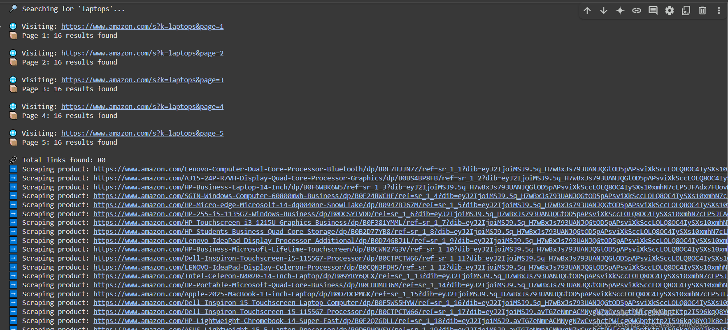

GitHib Link :

https://github.com/ahmedwaleedk/Amazon_Crawling